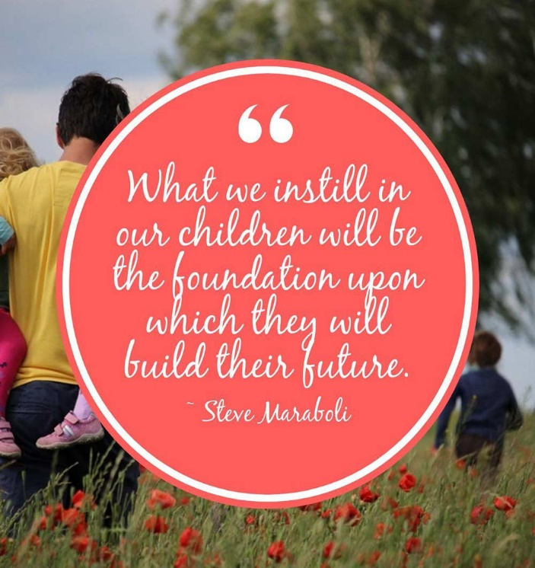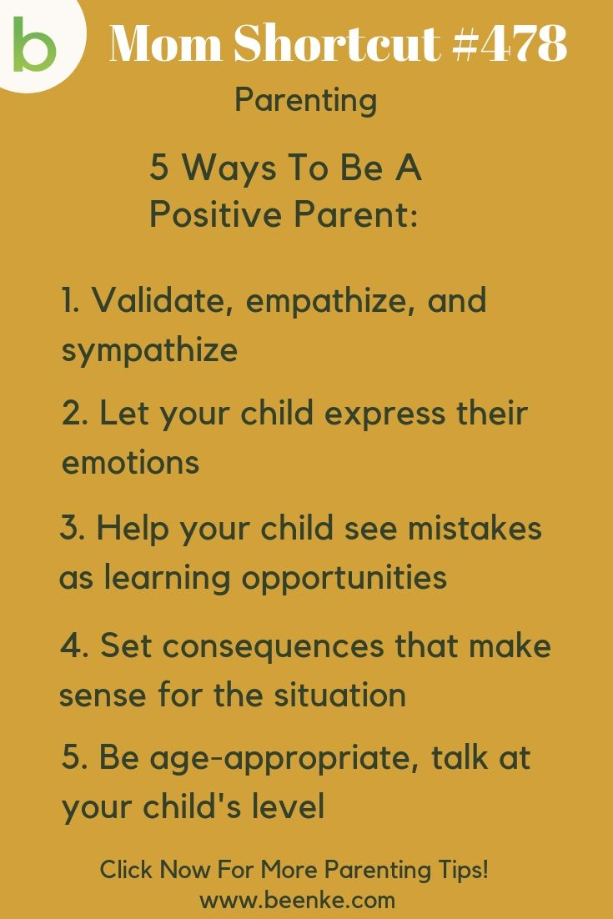

Parent Orientation Programme

A Parent Orientation Programme was held in the Birla Public School auditorium for the parents of grade III and IV on 5th October, 2019. This was aimed predominantly to maximize on the untapped potential and demonstrate a positive attitude in our students. The school Principal, Mr. A P Sharma, addressed the gathering. In his speech, the Principal gave guidelines on effective parenting. He emphasized on spending quality time with their kids starting from breakfast. He also suggested different measures for the overall development of the child.

This proved to be a sincere effort made by the school in educating the parents to look after and guide their children in a proper manner. Overall it was a fruitful meeting and the parents were in high spirits after attending the orientation programme

**Feedback from parents**

“Today’s orientation program was excellent and useful tips we have got. Thanks to Sir Sharma and all.”   
 **[Mr. Ibrahim, Parent 4G**]

“I liked the session very much it was a great refresher for parents.”   
 **[Ms.Veena Cooper, Parent 3 J]**